|  |  |  |
| --- | --- | --- |
| **LAB221 Assignment** | **Type:** | **Short Assignment** |
| **Code:** | **J2.S.P0122** |
| **LOC:** | **50** |
| **Slot(s):** | **1** |

**Title** Colors Slider

**Background Context**

The RGB color model is an additive color model in which red, green, and blue light are added together in various ways to reproduce a broad array of colors. The name of the model comes from the initials of the three additive primary colors, red, green, and blue.

The main purpose of the RGB color model is for the sensing, representation, and display of images in electronic systems, such as televisions and computers, though it has also been used in conventional photography. Before the electronic age, the RGB color model already had a solid theory behind it, based in human perception of colors.

A color in the RGB color model is described by indicating how much of each of the red, green, and blue is included. The color is expressed as an RGB triplet (*r*,*g*,*b*), each component of which can vary from zero to a defined maximum value. If all the components are at zero the result is black; if all are at maximum, the result is the brightest representable white.

In computers, the component values are often stored as integer numbers in the range 0 to 255, the range that a single 8-bit byte can offer. These are often represented as either decimal or hexadecimal numbers.

**Program Specifications**

Design a program that allows users change color using slider

***Function details:***

1. Program has three slider to change three colors (R,G,B).
2. Program has a rectangle fill color you changed.

***Expectation of User interface:***

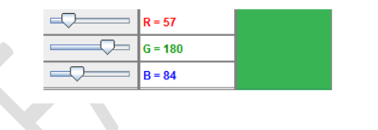

**Guidelines:**

Using JSlider to store value three colors red, green and blue.

Using addChangeListener method to register event.

Using ChangeListener to implement stateChanged method.